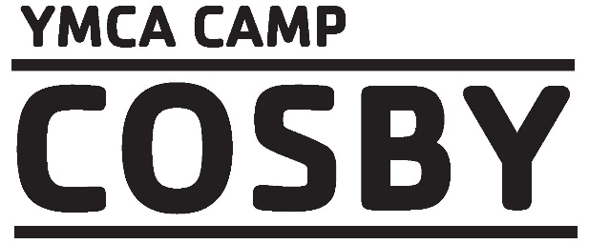
Ways to Save!
Name | To Receive Discount | Discount Description | Amount
YMCA  Member | Call or e-mail to get  Discount | YMCA members receive a $50 discount per session per child as part of their YMCA Membership benefit. | $50 per  Session per  child
Military | Call or e-mail to get  Promo Code | Children of active and veteran military parents/ guardians receive a onetime $50 discount on family balance. | Onetime  discount of $50 per family
Nurse  Volunteer | E-Mail syork@ymcabham.org to learn more. | Volunteer as a camp nurse and receive a discount on camp tuition. Contact camp to learn more. | Depends on volunteer commitment
Multi- Session Discount | This discount automatically applies to your final balance as you register for multiple weeks. | Multiple Session Discount applies to all regular camp sessions. After the first session families will receive $15 off per child, per session for each additional session. | $15 off per each additional session
Sibling Discount | This discount automatically calculates as you register and is applied to your family balance. | After 1st child is registered a $25 discount will apply to all additional children in the family. This is a onetime discount that will be applied to family balance. | Onetime $25 discount for second child and each additional child
Full Time Staff | Call or e-mail to get Promo Code | Employee receives 100% discount for 1 week session | Onetime 100% discount for household family members
Part Time Staff | Call or email to get Promo Code | Employee receives 50% for 1 week session | Onetime 50% discount for household family members

